​

**​**

**​**

**​**

**​**

​

**​**

**​** 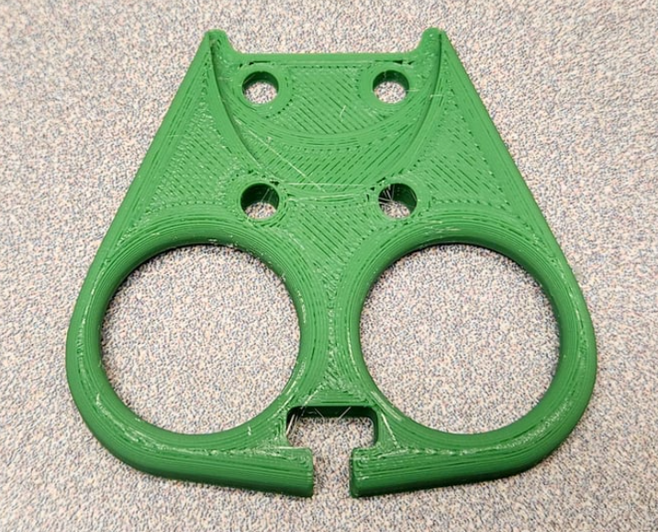

**​**

**​**

**​**

Plug Puller

**​**

​Plug Puller

**​3D Printing, Soldering, and Assembly Directions**

**​**

​Author: Braeden McDonald

​Model Creator: Brennan WATAP​

Plug Puller

Shape rectangle

**3D Printing Instructions**

1.) Download the device file from the virtual library.

2.) Open PrusaSlicer and click the “Add…” button (The cube at the top left in figure 1) then select the device file from the downloads folder.

Figure 1

3. Go to the “Print Settings” tab in the top left corner of PrusaSlicer and change the number of perimeters to 4 (see red arrow in Figure 2). Then double-click on the “Infill” subtab (see blue arrow in Figure 2).

Figure 2

4.) Change the fill density to 50% and the fill pattern to Gyroid (see red box in Figure 3).

Figure 3

5.) Go back to the “Plater” tab in the top left corner of PrusaSlicer. Then click the “Print settings” drop-down menu and select the 0.20mm Structural option (see red arrow in Figure 4).

a. Note: The titles of each print setting option will vary slightly between printer models, so there may not be an option matching this wording exactly. What’s important is that you select one of the 0.20mm options.

Figure 4

6.) Open the Filament drop-down menu (see blue arrow in Figure 4) and select the filament type you want to print in. a. Note: The recommended material for this device is PLA, but PETG is also acceptable.

7.) Open the Printer drop-down menu (see green arrow in Figure 4) and select your printer make and model. a. Note: If you don’t see your specific printer in the drop-down menu, follow these instructions to add them:

https://help.prusa3d.com/article/configuration-wizard_1754

8.) Click the “Slice now” button in the bottom right corner of PrusaSlicer and wait for the software to finish slicing the file.

9.) Once the slicing is finished, click “Export G-code” (see Figure 5) and save the G-code to a flash drive

Figure 5

10.) Insert the flash drive into your 3D printer, select the G-code and print

**Soldering Instructions**

N/A

**Assembly Instructions**

N/A